COSC 4333: Distributed Systems
Assignment 3
Due: 10:00am, Oct. 4, 2024 (Friday)

Name: _____Andrew Kalathra______

LUID: ____L20498001______

Date: _______10/04/2024_______

(15 points) 1. In the OSI model, what are the seven layers and their functionalities?
- Physical Layer – This is the lowest level, giving details about transmission medium and hardware. All specifications consist of relations to electrical properties, radio frequencies, and signals. This layer provides services to upper layers.
- Data Link Layer – On the same network, data is passed through this layer by being split into packets or chunks. This layer is used for intra-network communication.
- Network Layer – Data that is transferred between different networks utilizes this layer (same network communication does not need/use this layer). Segmentation of packets is done on this level when necessary.
- Transport Layer – This is where the data is actually transferred from one device (sending the chunks) and assembly of chunks by the receiving device.
- Session Layer – This layer opens and closes communication between devices, staying open while data is being transmitted, and closing after. Synchronization occurs at this level.
- Presentation Layer – This layer prepares the data to be presented by the application layer. Encryption and decryption are done here, making the data readable. Compression is also done here to reduce the data size and improve communication efficiency.
- Application Layer – This gives the user a way to interact with what is being sent or received. This layer specifies how a pair of applications interact when they communicate, with specifics of format, meaning of messages applications can exchange, and the procedure.
- Resource: https://www.cloudflare.com/learning/ddos/glossary/open-systems-interconnection-model-osi/

(15 points) 2. What are the advantages of disadvantages of user-level threads? What are the advantages of disadvantages of kernel-level threads?
- User Level Threads
  - Advantage
    - No thread-support from the OS
    - Lightweight, usually only the CPU register values need to be stored and subsequently reloaded
  - Disadvantage
    - Invocation of a blocking system call will immediately block the entire process
- Kernel Level Threads
  - Advantage
    - If blocked, the kernel can reschedule another thread
  - Disadvantage
    - Slow
    - It is expensive to create and switch threads

(10 points) 3. What is the advantage of using virtualization when designing a system?
- You can host multiple virtual machines on one computer, each running a different OS.
- This makes the software at the application (or higher levels) stable, even when lower levels change quickly.
- This is also portable, flexible, and allows you to test applications on multiple devices to find and isolate any faults before release or actual testing. Even in testing, this allows bad code to be localized to a virtual system and not affect an actual system.

(60 points) 4. This question is about setting up a Virtual network based on VirtualBox and Ubuntu.
Watch those videos posted under the folder Class Video/How to Build a Virtual Machine. After watching:
- please create a Virtual Network consisting of three Ubuntu machines.
  - 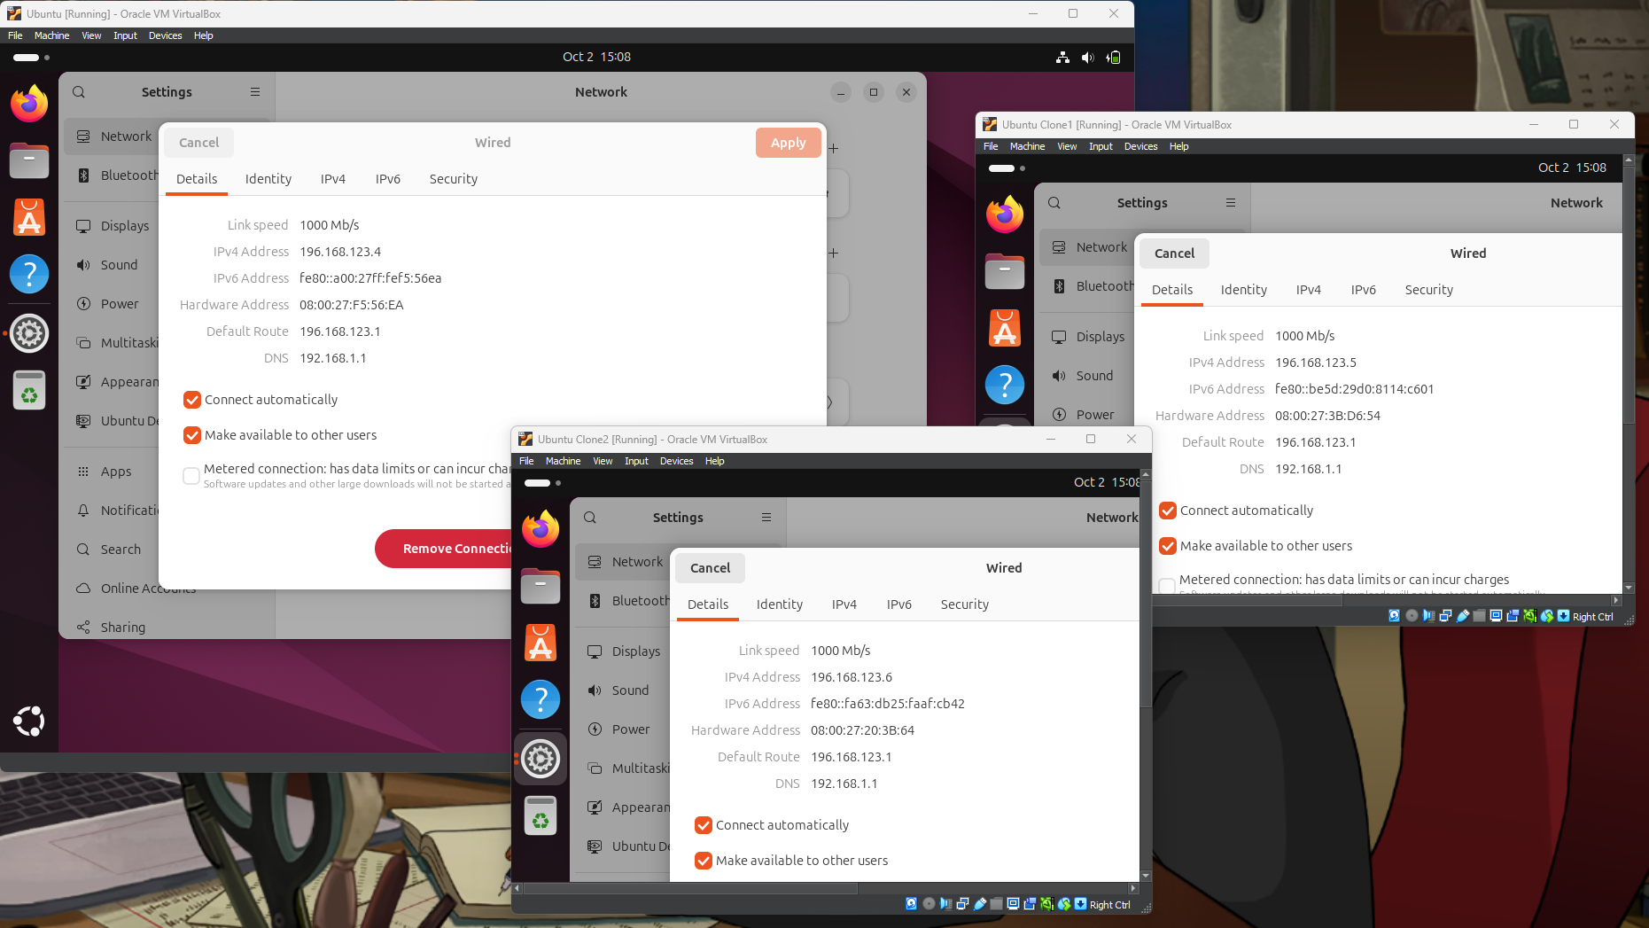
  - As we can see, there are three separate Ubuntu machines running at the same time, all connected to the same LAN.

- please run webclient.c and webserver.c (used in Assignment 2) on two separate Ubuntu machines, and give a demo about how to run webclient and webserver and how webclient and webserver interact.
  - 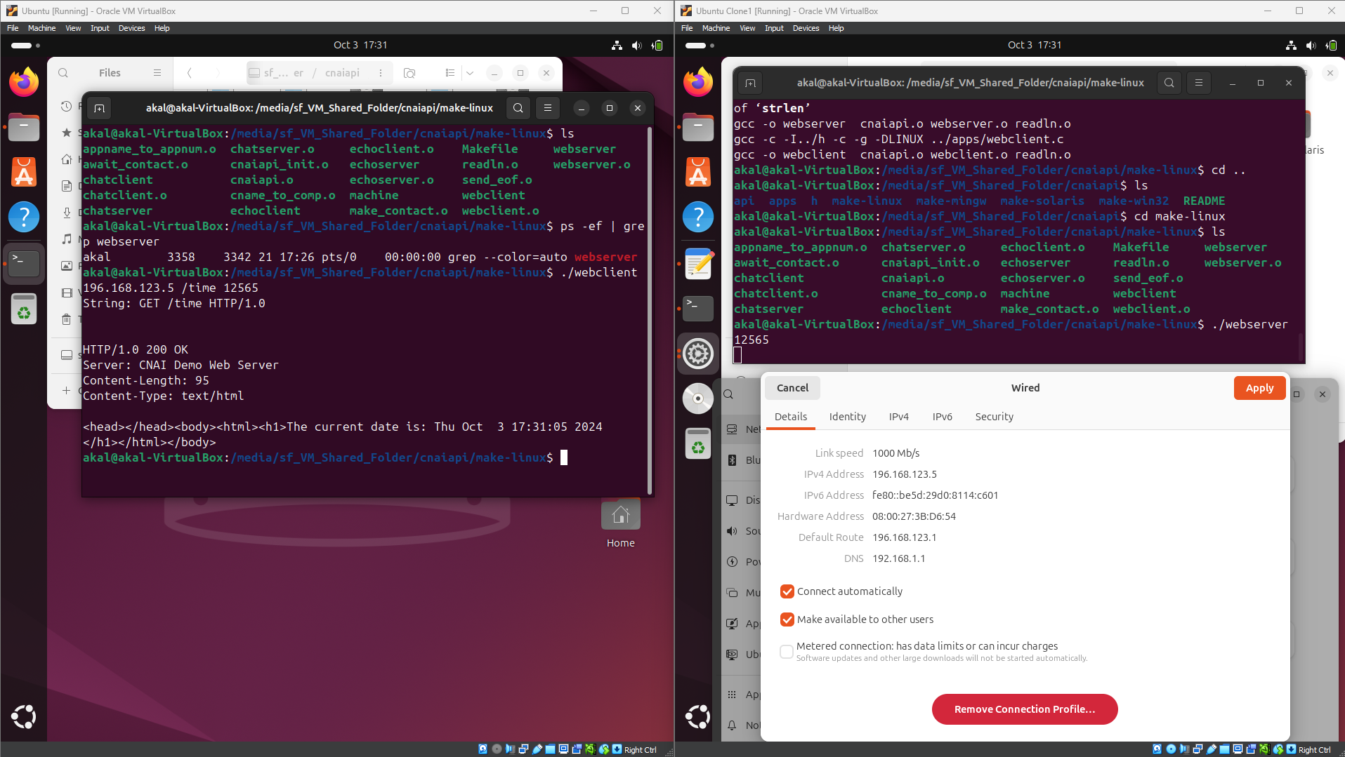
  - As shown, two different Ubuntu machines can be used to run webserver (left) and webclient (right).
  - Using the IP address of the server and the specified port, the webclient will be able to access the webserver. Using the predefined function of /time, the server was able to respond to the request with HTML code with the current time using the necessary HTTP protocol.
For the above-mentioned step a) and b), please turn in screenshots
How to Turn In:
Softcopy: Please use BlackBoard to turn in your homework solutions.

